To login to the software, browse to our website; abcsignproducts.com
and select Software. At the pull-down menu select “Engineering”. This will get you to the Engineering Login screen.
Use your email address for the username. Your password is Abc123!
You will enter a screen called “My projects”:
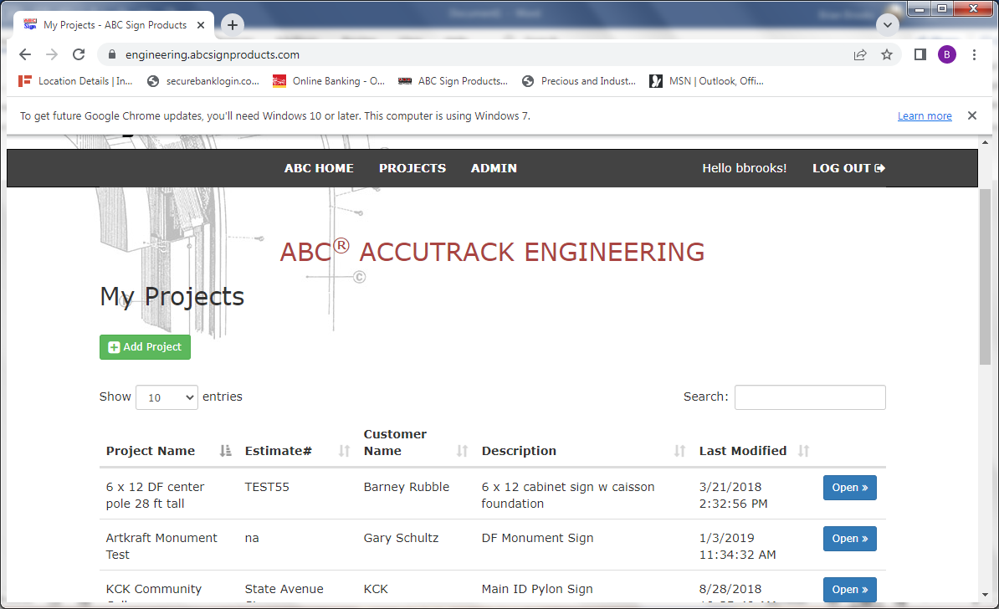
Click on the Green Button that says, “Add Project”. Enter project information (as shown).
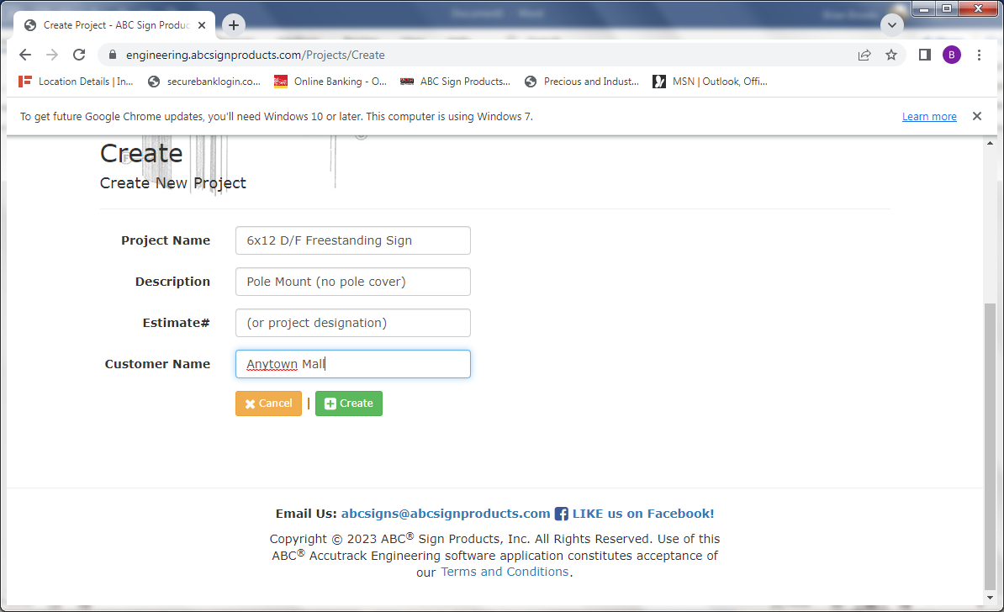
Click on the Green “Create” button. Your new project will be saved in “My projects” with all projects you have entered in the past. Click on the blue “Open” button. At the “Project Detail and Calculations” screen you can edit or delete a project, or you can click on the green button to “Add Calculation”.
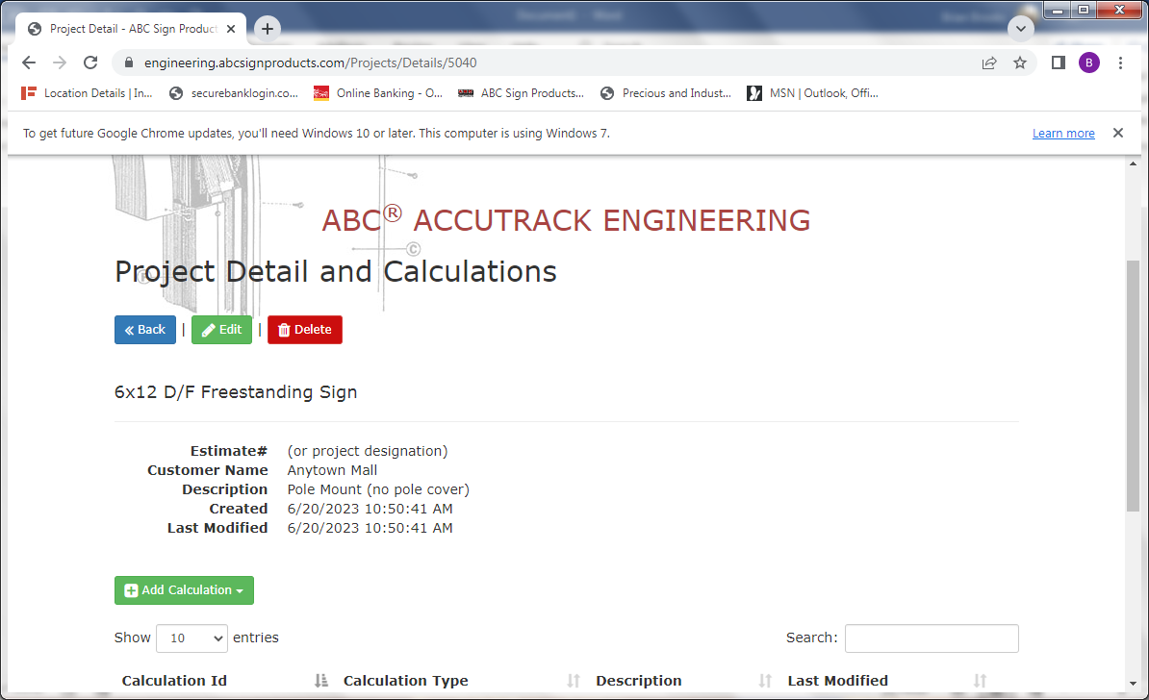
When you click on “Add Calculation”, a drop-down menu will appear. The most common type of foundation will be “Caisson Foundation” with direct burial of the support column. Spread foundations are required if soil conditions are very soft or sandy, and in low-lying areas prone to moisture. If you are using anchor bolts with base plates you can calculate plate and bolt requirements with that selection.
Select “Caisson Foundation”.
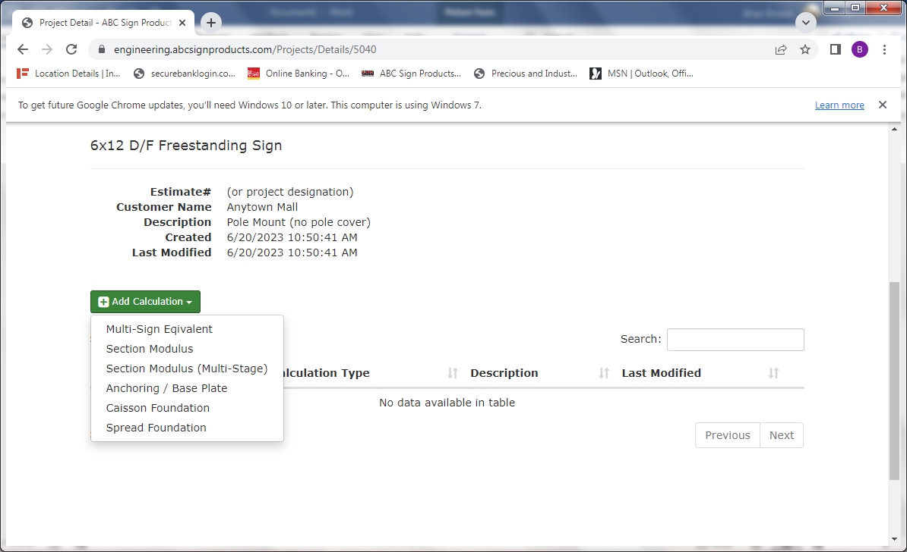
You will be taken to the screen for Caisson Foundations:
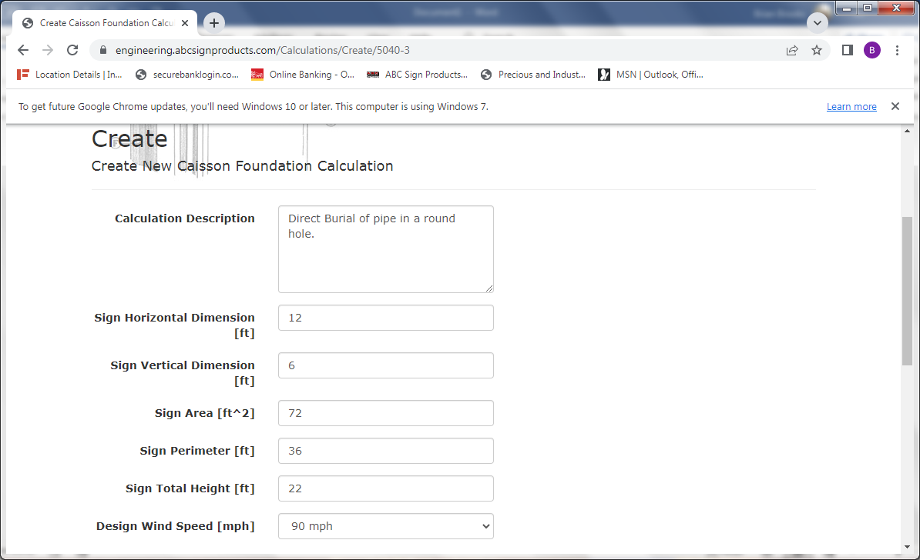
Enter the appropriate details and dimensions. Click on the down arrow to enter the Wind Speed. Select the appropriate windspeed for the location where the sign will be installed. Circular Foundations are economical; excavating with an auger. Square or rectangular are typically dug with a backhoe.
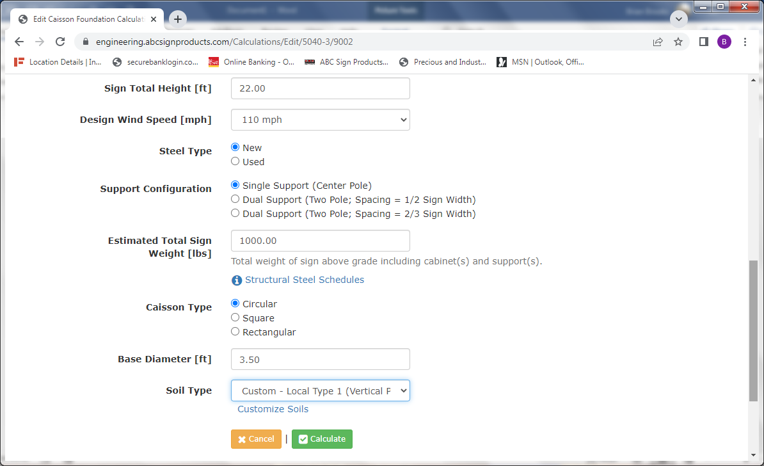
Select “New” or “Used” steel and the appropriate number of columns. If using a two-column configuration, select the spacing between columns that most closely matches your project. Select the desired shape of the caisson and the dimensions. Select the correct soil type or enter custom soil pressures if available. Then, click on the green “Calculate” button.
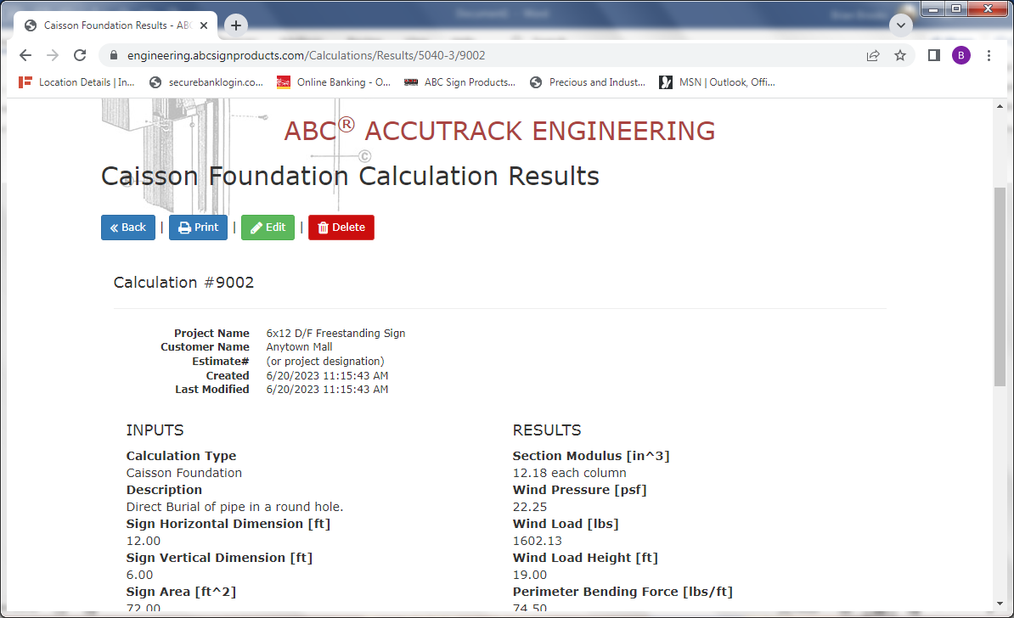
The calculated results will appear. You can print them and save a hard copy, or you can come back later to view or edit the results if necessary. You may also delete just this example without deleting the entire project or other examples. This allows you to run several examples for a project if desired to determine the most practical or most affordable options for the foundation.
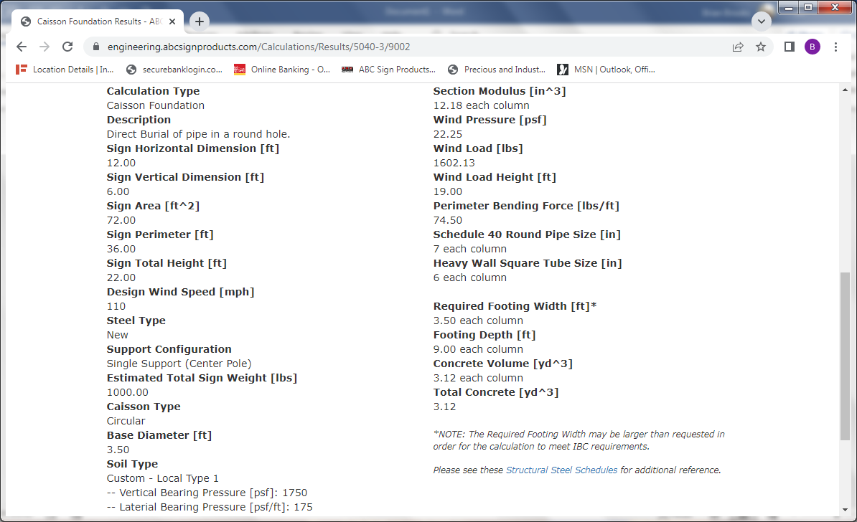
Recommendations for pipe or square tube sizes are provided in the right column near the bottom. The required depth of the footing and quantity of concrete are displayed. To decrease the depth of the hole, increase the width or diameter of the caisson. This will increase the quantity of concrete needed. To explore other options available in the software, enter test projects with hypothetical parameters. These can be deleted after you have become more familiar with the software.

